**MODULE 4**

**ASSIGNMENT 1**

**Logical Operators**

**1) Check whether the file exists and is executable using logical operators.**

**Hint:man test**

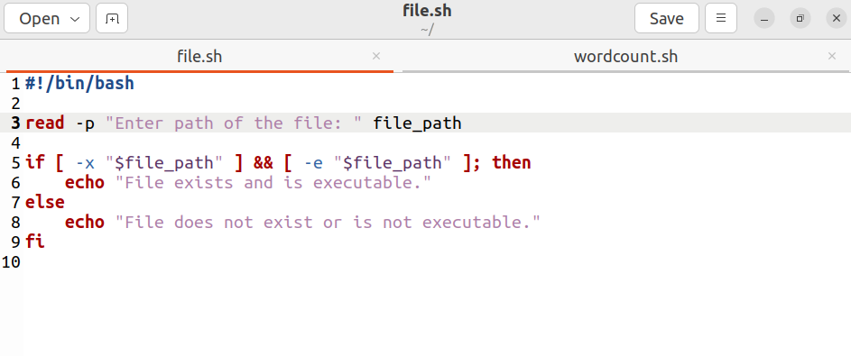

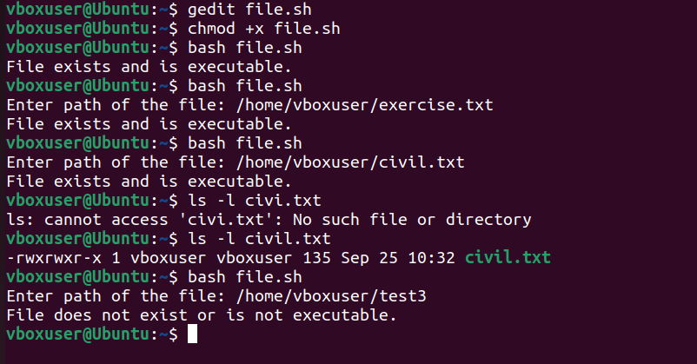

**ASSIGNMENT 2**

**Arithmetic Comparison**

**1) Write a program to demonstrate the use of not equal to operator.**

**Hint: -ne**

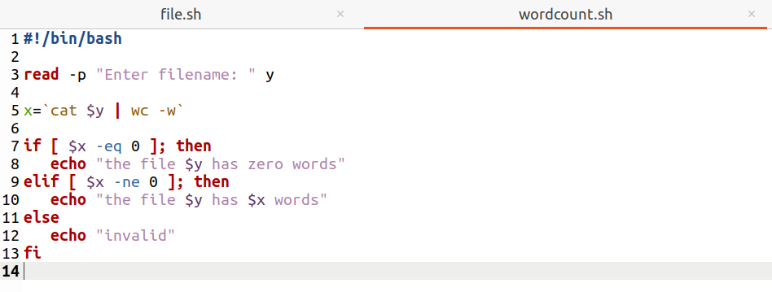

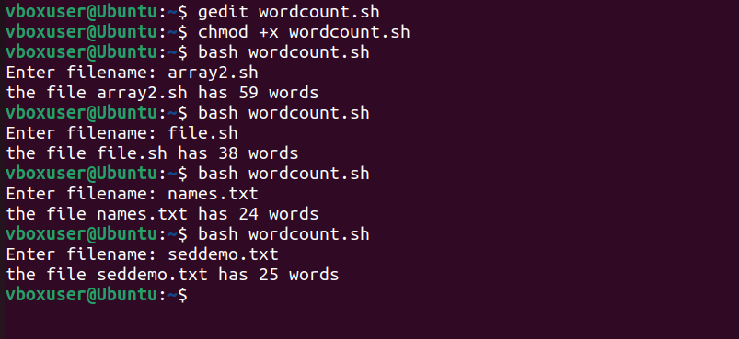

**ASSIGNMENT 3**

**String and File attributes**

**1) Explore some more attributes**

**-r**

**-x**

**-o**

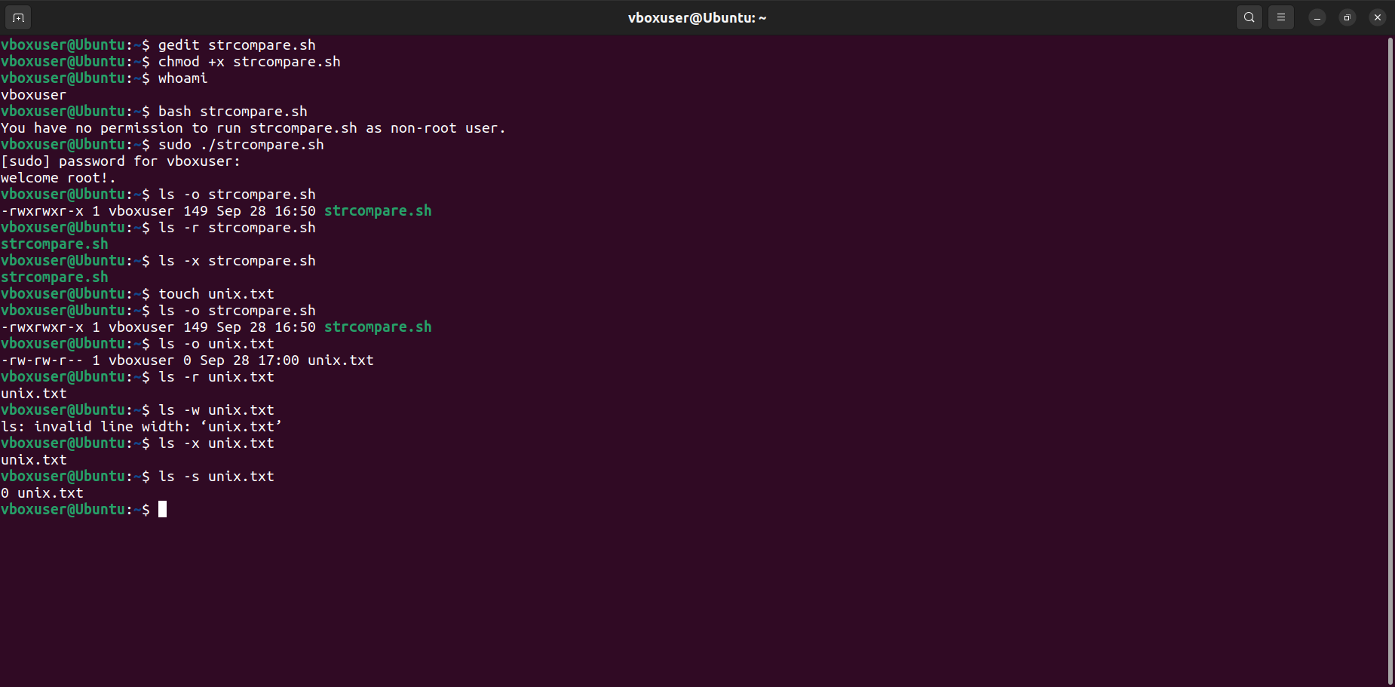

**ASSIGNMENT 4**

**Conditional Loops**

1. **Find the sum of first n prime numbers.**

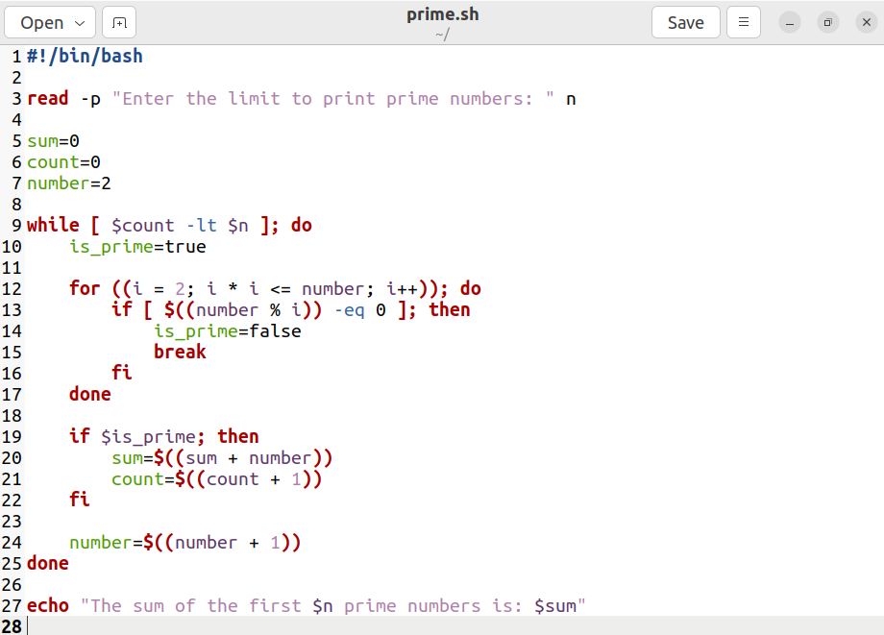

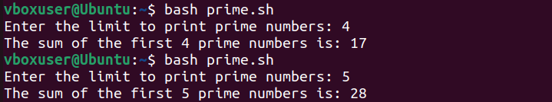

**ASSIGNMENT 5**

**More on Loops**

**1) Retype nested-for.sh bash script using nested while loop**

**2) Save your program with the name: nested-while.sh**

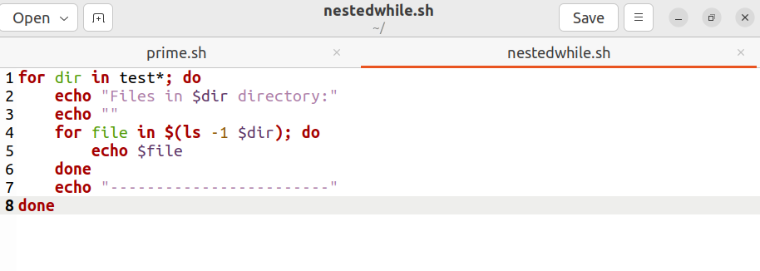

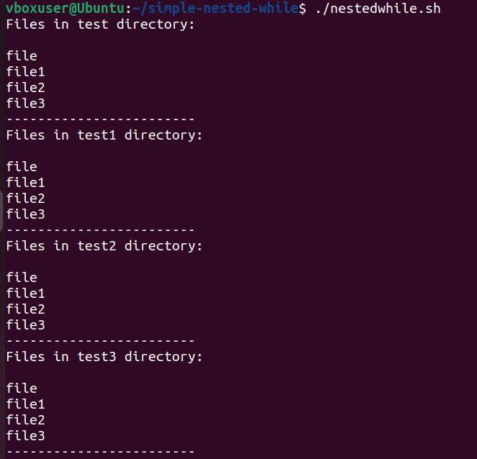

**ASSIGNMENT 6**

**1) Write a menu driven program for mathematical calculation**

**a. It should take user inputs a and b**

**b. It should ask for mathematical operator (+, -, / and *).**

**c. Do the calculation**

**d. Print the output**

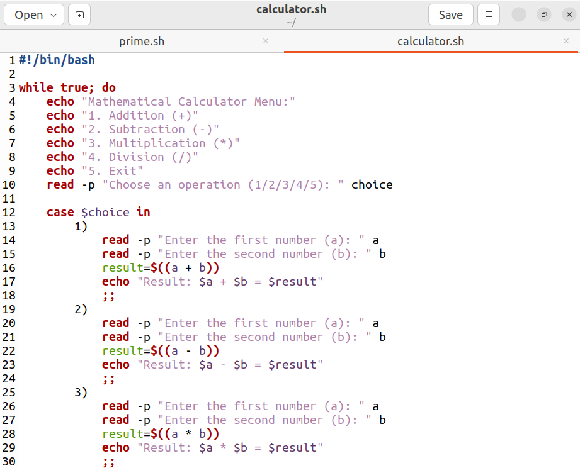

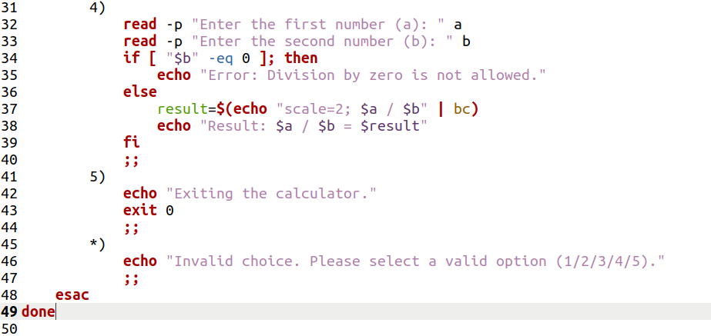

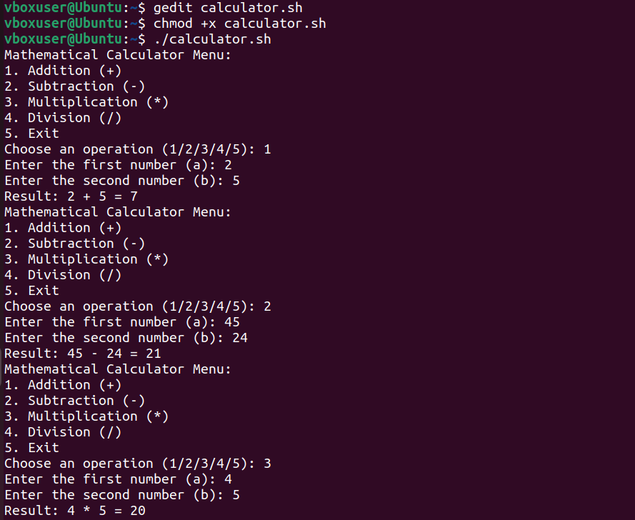

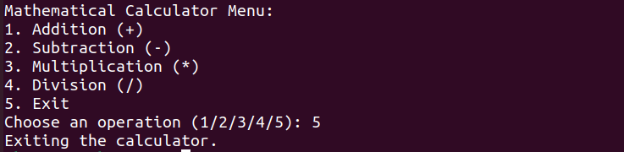

**ASSIGNMENT 7**

**Using File Descriptors**

**1) Try to append few lines to a file test.txt using file descriptor.**

**2) Display the content of the file using file descriptor.**

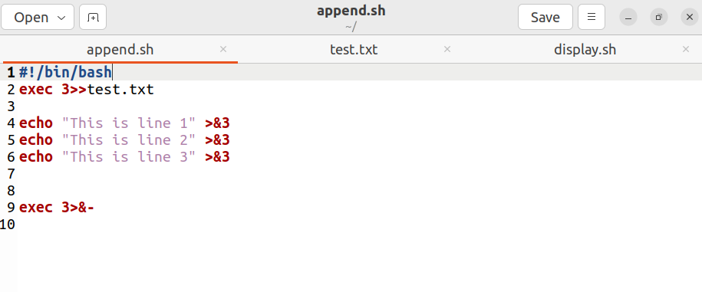

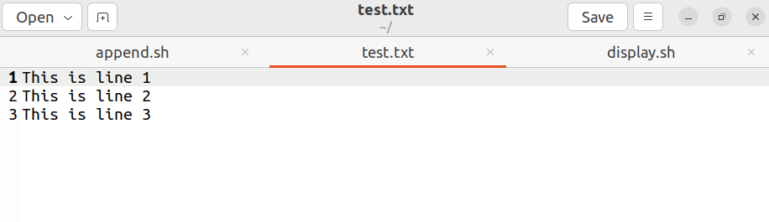

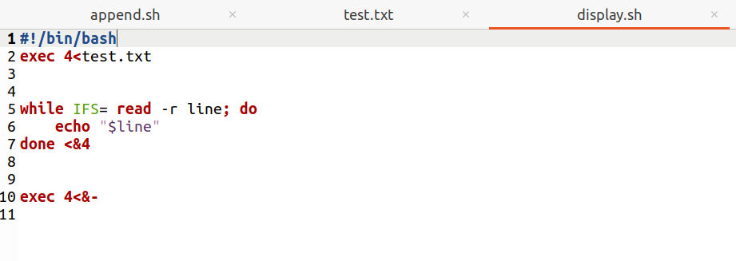

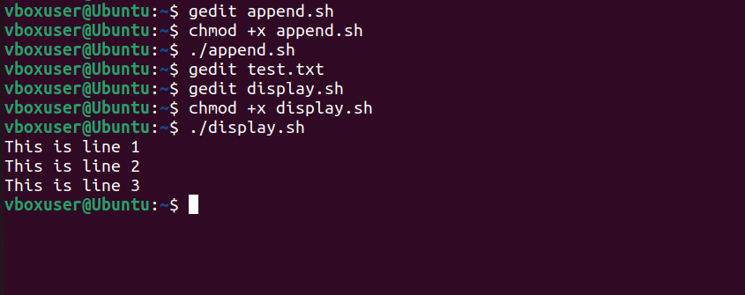

**ASSIGNMENT 8**

**Basics of functions**

**1) Write a program with two functions:**

**a. The first function should display diskspace usage in human readable form.**

**(Hint: df -h)**

**b. The second function should display filesystem usage in human readable form.**

**(Hint: du -h)**

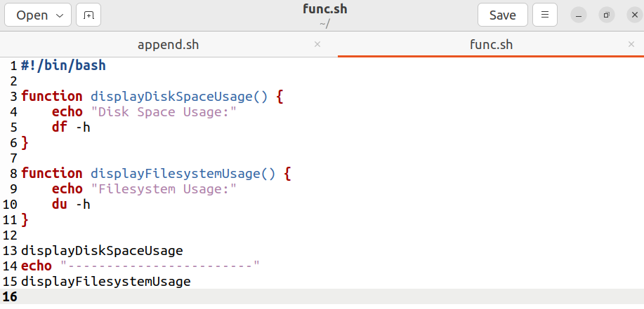

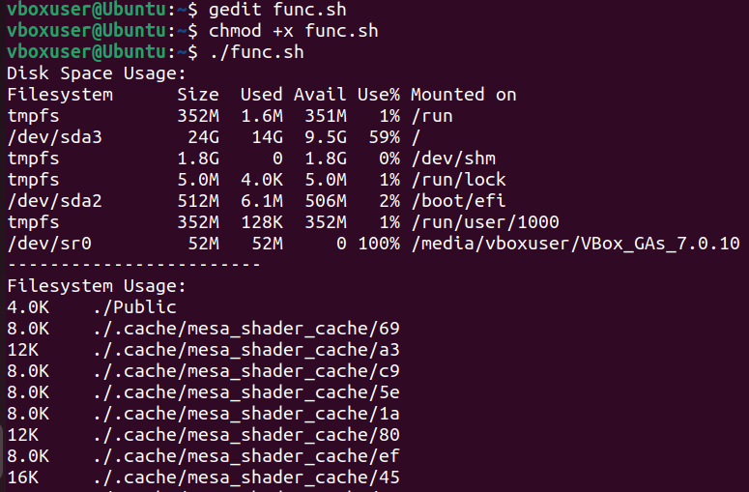

**ASSIGNMENT 9**

**More on functions**

**1) Write a program,**

**a. where the function accepts two arguments.**

**b. The function should multiply the two arguments.**

**c. Make 3 function calls with arguments - (1, 2), (2, 3) and (3, 4)**

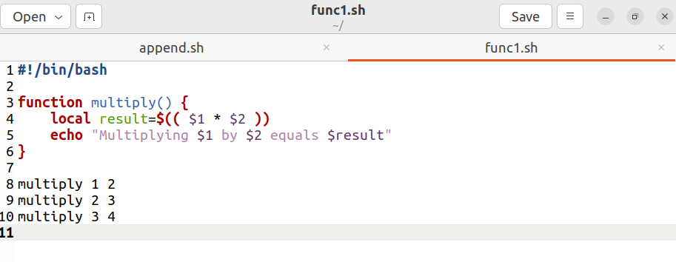

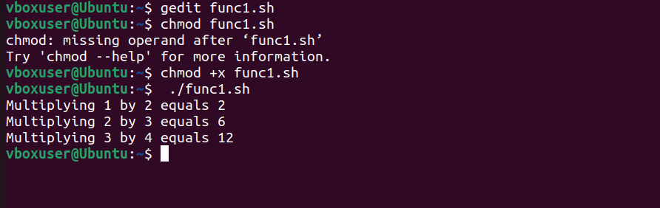

**ASSIGNMENT 10**

**Arrays and functions**

**1) Write a program,**

**a. Where a function adds all the elements in an array.**

**b. The function should display the sum of elements.**

**c. Make 2 function calls with array elements- (1, 2, 3) and (4, 5, 6).**

